Smart, Cross-Platform Binary Visualisation Tool

Ong Bee Lee
School of Computer Science and Engineering

Assoc. Prof. Yeo Chai Kiat
School of Computer Science and Engineering

Abstract - Binary visualisation (binvis) is superseding the traditional way of file analysis. The visuals created can expose the underlying structures of an arbitrary sequence of bytes which otherwise cannot be seen in a hex editor, making it useful for general file identification and possible malware detection. Given the great volume of files moved on the internet today, there is a need for automation in this field. Currently, there are efforts to develop some intelligence to detect certain binary patterns in arbitrary files, which mostly utilise simple classifiers on raw byte sequences. However, none of them explored the use of intelligence to process the visuals generated from the binvis tools. Hence, this paper details the development of a smart, cross-platform binvis tool, written in Java that uses an open source deep learning library. In addition, a web crawler was created to obtain a large sample of the common file types used on the internet. These files were processed into digraph visuals which were fed into a convolutional neural network implemented via the library. Unfortunately, the classification labels used and the existence of compressed data (which added noise to the resulting digraph visuals) meant that the classification was not effective enough to be of practical use. In spite of this, deep learning for binvis could be further explored by using classification labels based on the fundamental data formats (e.g. text, bitmap image, etc.) and supplementing the digraph data with some other known visual techniques.

Keywords – binary visualisation, artificial intelligence, neural network

1 Introduction
A computer file is fundamentally a sequence of binary digits (bits) that can be read and processed by a central processing unit. In practice, this binary sequence is stored as a sequence of 8-bit bytes. In most filesystems, each file is identified by its filename and possibly an extension to indicate its purpose (e.g. “.exe” for executable files). However, filenames and extensions may not reliably provide cues about a certain file as they can be arbitrarily assigned.
As computer security remains as one of the biggest technological challenges faced today [1], file analysis is one way to detect malicious softwares (malwares) that disguised themselves as harmless files. Traditionally, to analyze a given file, the user would open the file in a hex editor, which is a tool that formats and displays each byte in the file as a hexadecimal digit. This method provides a low-level view of the file but relies on the user’s knowledge of common byte sequences or patterns for interpretation.
A more recent development in file analysis is the use of binary visualizations (binvis) to exploit the ability of the human’s visual cortex that far exceeds the capability of any machine in identifying visual patterns. To visualize a file, a sliding window of bytes within the file is usually extracted and processed into an image based on some well-defined processing scheme. The simplest of such schemes is the bytemap that transforms each consecutive byte in within the sliding window to its corresponding pixel in the output image, whose intensity is proportional to the byte value. Nataraj et al. employed this visualization along with image processing to create a malware detection tool [2].
Existing binvis tools such as binvis.io [3] and, more recently, Veles [4] are available for general public use. The latter is more advanced, providing an extensible suite of tools to aid in file analysis. Veles represents a significant improvement over the proof-of-concept, all-in-one binvis tool developed by Conti et al. [5]. Though many visual aids are implemented, proper understanding of a file under analysis still heavily depends on the user’s knowledge.
Given the large volume of files being transferred today, many of which contain some form of malicious payload, there is a need for automation in the area of file analysis.
Hence, in this report, a smart binvis application is developed which feeds one of the generated visualizations into a pretrained convolutional neural network (ConvNet) that outputs the probable file type that can be ascertained from a certain sliding window of bytes.
By having an automated classifier, it is envisioned that malicious byte sequences can be quickly filtered away without much user intervention. However, the visualization that was used as input to the ConvNet may not be adequate for practical classification by the neural network.
In the next few sections, the design and implementation details of the application are discussed, followed by an analysis of the application and its limitations.

2 IMPLEMENTATION

2.1 Prerequisites
The software requirements for the project are as follows:
1. Java Runtime Environment 1.7
2. Java OpenGL library (JOGL)
3. DeepLearning for Java (DL4J)
The listed prerequisites are platform independent. By loading the correct native library based on the host platform, the application can be executed.

2.2 Application Design
The application is designed to adopt a layered architecture as seen in Figure 1..

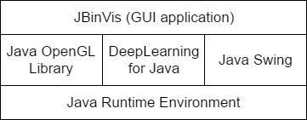

Figure 1 3-tiered architecture.
JOGL provides the means to utilize the OpenGL renderer for all visualizations. The core functionalities of the application are implemented by wrapping the OpenGL Java bindings, abstracting them away from the higher level visualization logic. Another library, DL4J, is an artificial intelligence library used to process one of the generated visualizations (the digraph plot). To display the Graphical User Interface (GUI), the Java Swing package is used for all the common controls (panels, menus, buttons, etc.).

2.2.1 File Cache
To provide support for all files regardless of their size, a caching scheme is implemented similar to the direct-mapping scheme of the Central Processing Unit (CPU) cache. On initialization, the application prepares 10 “banks” that are indexed from 0 to 9; and each bank can hold 65,536 bytes.
When the application requests a certain offset to be read from an opened file, the application looks into the corresponding bank, whose index can be determined by performing a 16-bit left-shift of the offset, then obtaining the remainder upon division by 10. If this bank does not contain the valid bytes, then the application loads a bank-size worth of bytes from the opened file into the bank. Otherwise, the correct byte value at the given offset is returned. This process can be summarized in Figure 2.

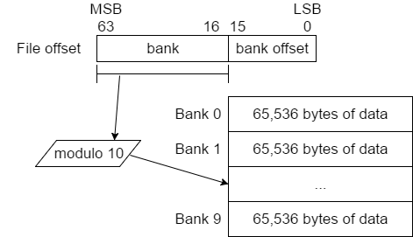

Figure 2 Direct-mapped cache scheme.
This method of caching is required as random access to files on the hard disk is slower than random access to the memory. Furthermore, the generation of the visualizations may require multiple reads to consecutive byte sequences, whose efficiency can be improved via caching.

2.2.2 Rendering
All OpenGL rendering is performed on a special Canvas control, GLCanvas. A class, BinVisCanvas, is derived from GLCanvas to implement facilities to swap a visualization logic at any time. Care is taken to ensure minimal usage of memory by only initializing the visualization logic once and that swapped out visualization logic can be reused later.
Each visualization logic is encapsulated as derivation of the abstract RenderLogic class. Globally, the application stores singleton instances of each available logic. As it is planned to have four visualization logic in this version, there are four corresponding RenderLogic-derived classes: Bytemap, Digraph, Trigraph and FrequencyHistogram. A simple class diagram depicting the interaction between the RenderLogic and the BinVisCanvas class can be seen in Figure 3.

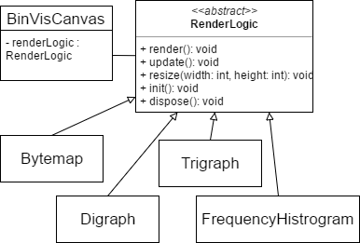

Figure 3 Integration between BinVisCanvas and RenderLogic

To maximize the use of the OpenGL renderer, wrapper classes are created to ease the management of OpenGL texture objects and OpenGL shaders. The OpenGL shader language (GLSL) is extensively used to render the digraph and trigraph plots as it is more efficient to use a programmable graphics pipeline to render such visualizations.

2.2.3 Visualizations
In the version of the application developed at the time of writing, there are four visualizations.
Firstly, the bytemap visualization (Figure 4) reads 65,536 consecutive bytes from an arbitrary offset in an opened file and maps each byte to its corresponding pixel (based on some transformation function) on the output image. The bytemap visualization is highly customizable, allowing the user to change the transformation function (between scanline or Hilbert curve) and pixel format, among many other settings.

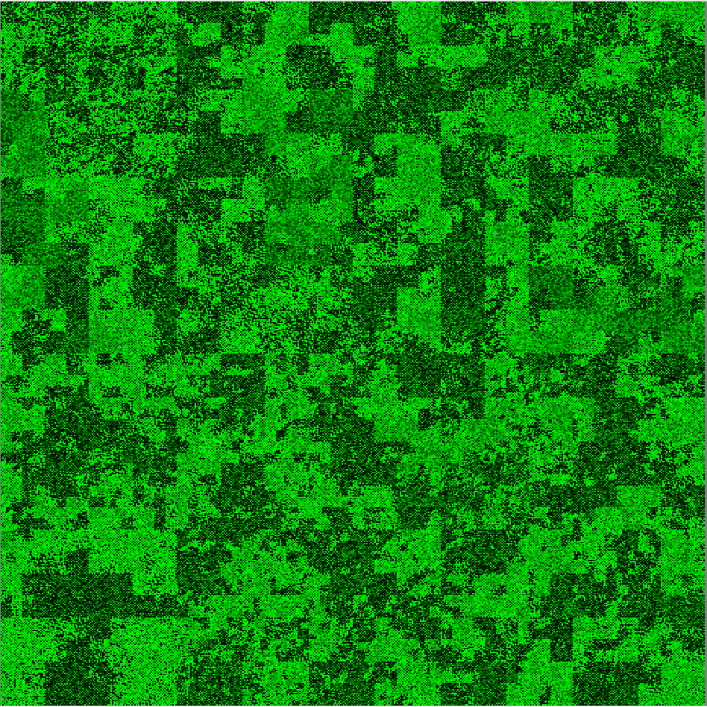

Figure 4 Bytemap view showing the Hilbert curve mapping.
Next, the digraph and trigraph visualizations are implemented. In the case of the digraph visualization, every consecutive digram of bytes within an 8192-byte sliding window is mapped to a 256x256 frequency matrix, M. In other words, every element M_{ij} (where 0≤i,j<256) corresponds to the frequency of the digram (i,j) within the sliding window. The resulting matrix is put through a histogram equalization function before being rendered as an image to enhance the contrast (Figure 5). The process is similar for the trigraph visualization, except that the output is a 3-dimensional visualization. The rendering of the trigraph is done via volumetric rendering.

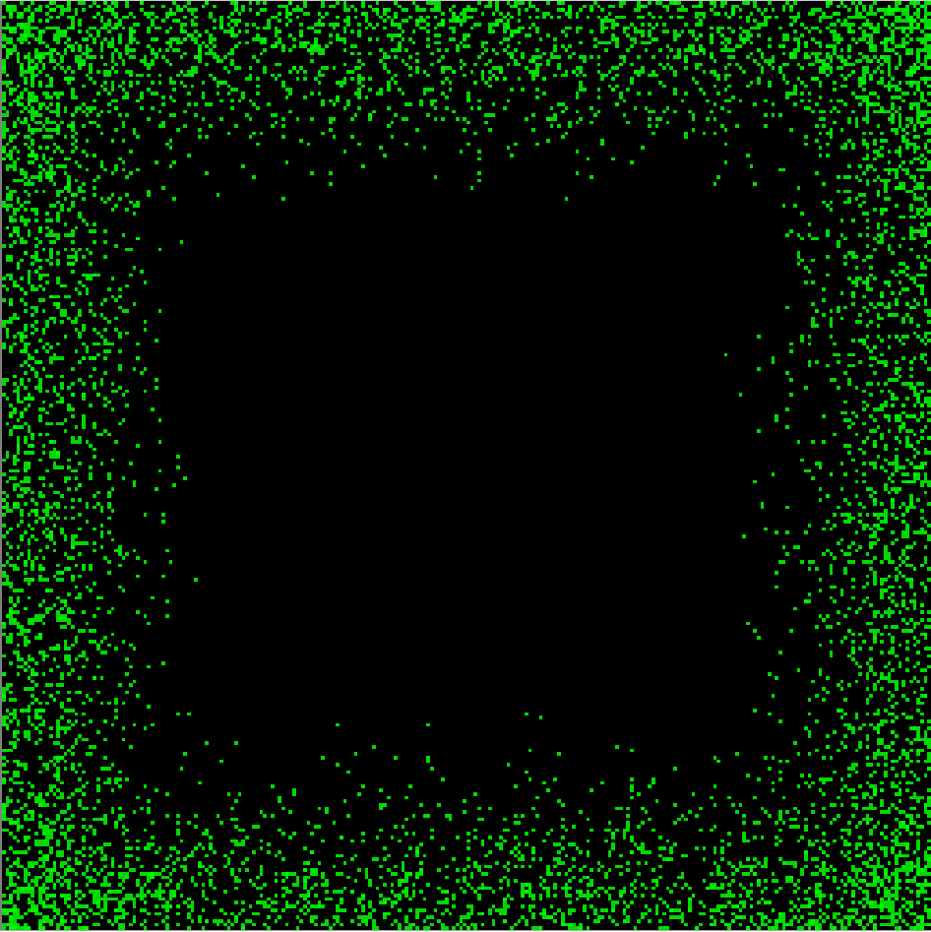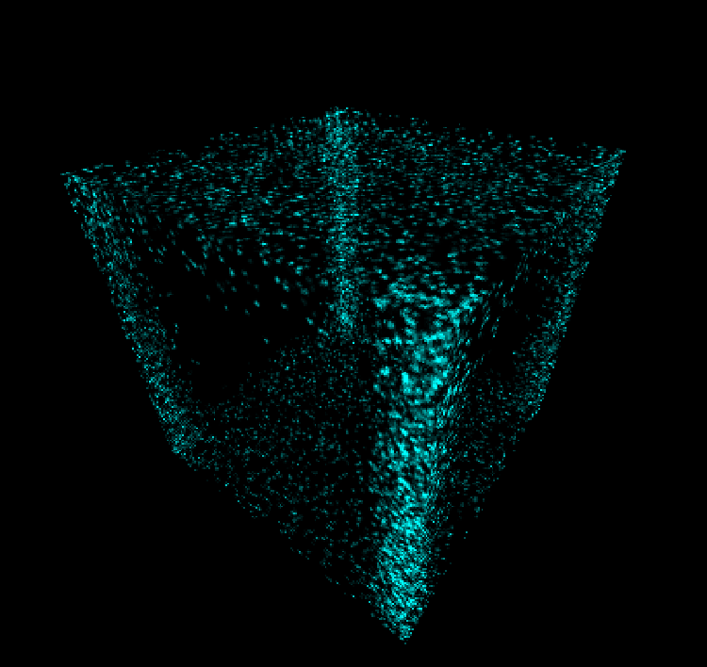

Figure 5 Digraph (top) and trigraph (bottom) visualizations of a wave audio file at the same offset.
It has been shown that the digraph (and, by extension, trigraph) are very effective in conveying otherwise hidden structures that exist within a file [6]. Hence, these visualizations were of high priority in the development time.
Lastly, the frequency histogram visualization plots the relative frequency of each byte value that occur within a 4096-byte sliding window. The histogram is normalized such that the mode is at 1.0 (peak value) as seen in Figure 6.

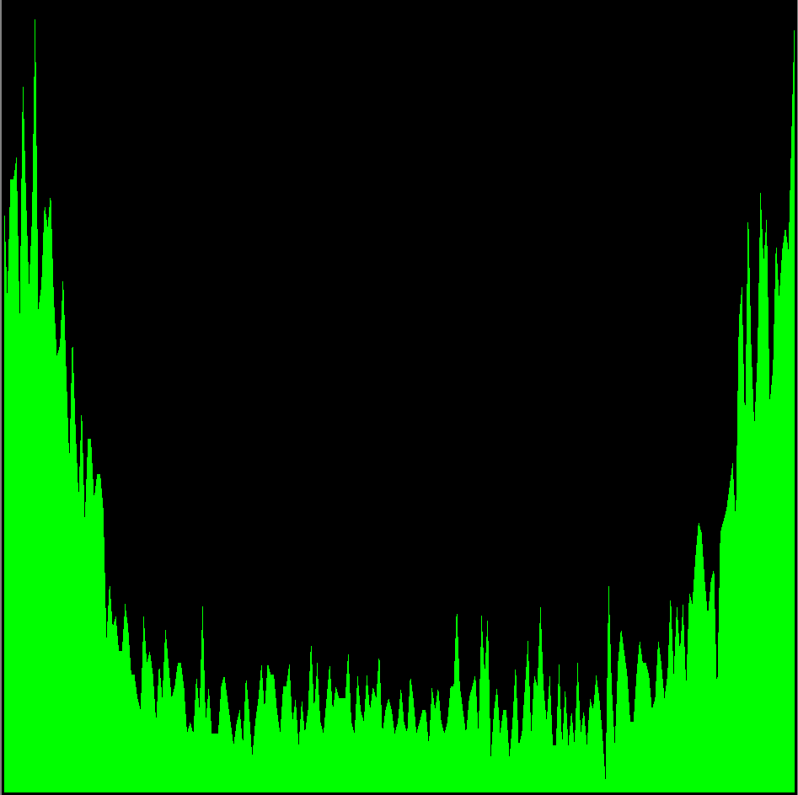

Figure 6 Freqeuncy histogram visualization.

2.2.4 Training and Sample Collection
To process digraph visualizations, a ConvNet was set up, which consists of 3 convolution layers and a dense layer of neurones interlaced with max-pooling subsampling layers.
A web crawler was also created to obtain sample files for the following file types: doc, gif, jpg, pdf, png, ppt and xls. These file types were chosen as they are commonly used and transmitted. 100 random digraph samples of each file type were fed into the network for training and evaluated. The network was then exported out to be incorporated into the main GUI application.

3 RESULTS and discussion
The GUI of the application can be seen in Figure 7..

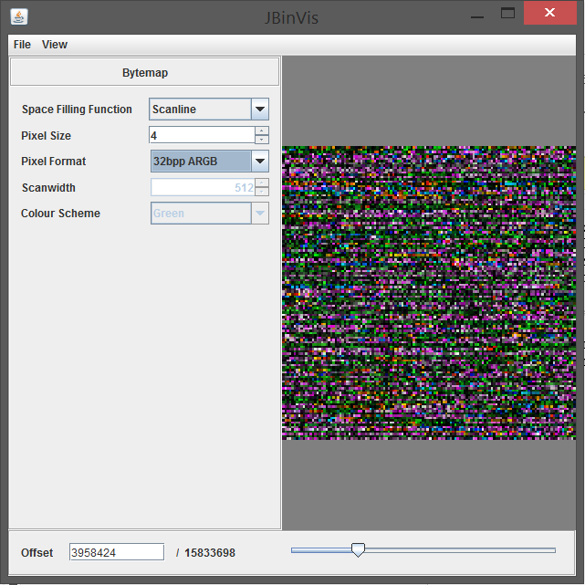

Figure 7 Screenshot of the GUI, showing the Bytemap parameters.
Using the trackbar at the bottom of the window, the user is able to “scrub” through any opened file with ease. They could also choose to input an arbitrary offset as they wish.
With the file cache system in place, the random sequential reading of files is tested to be 36-times faster as compared to that without the cache. This is important to ensure that the visualizations can be rendered in real time for user interactivity.

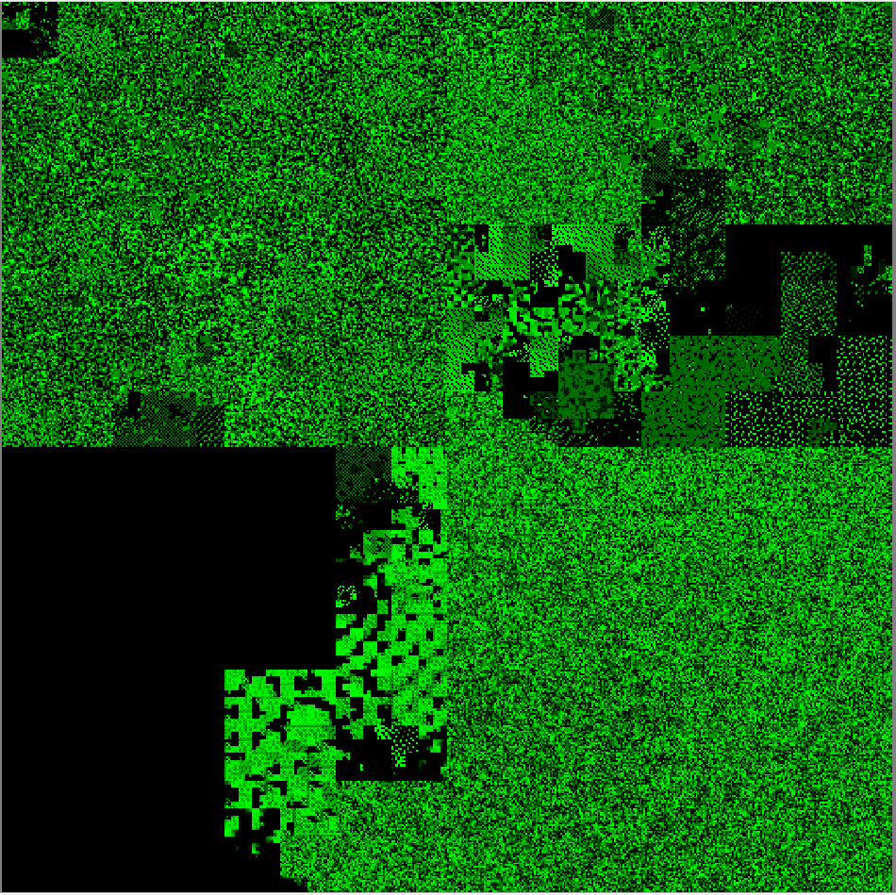

Figure 8 Bytemap analysis of notepad.exe
As expected, using the Hilbert curve mapping for the bytemap visualization, many structures which are otherwise not obvious in a hex editor can be seen (Figure 8). In addition, Hilbert curves have the property that they preserve locality – bytes that are close to each other in the file would be close to each other in the generated image.
Next, the digraph and trigraph views respectively show the signature for an embedded bitmap image, which can be resolved using the scanline mapping (Figure 9).

(a) 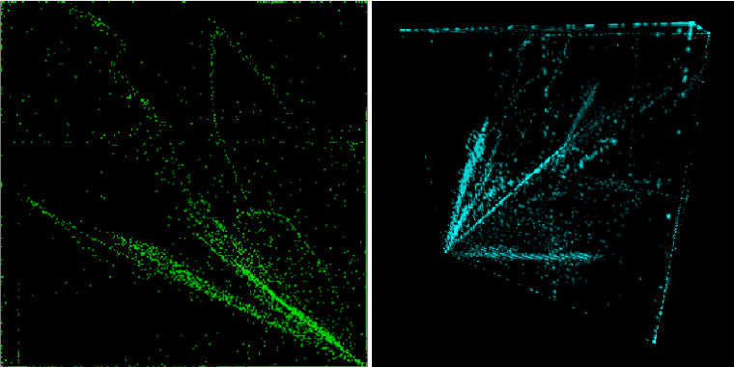

(b) 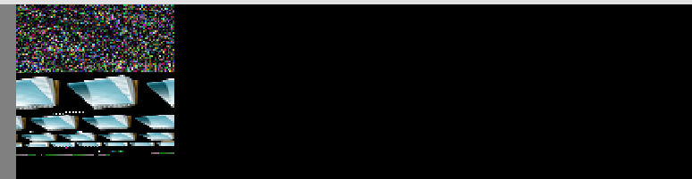

Figure 9 (a) Digraph and trigraph visualizations alluding the existence of an embedded bitmap. (b) The resolved image as seen in the bytemap view.
Though the visualizations work as intended, the ConvNet proved to be unreliable. In many of the file types tested, the byte sequences do not exhibit consistent pattern in their resulting digraph plots. This produced training data that provided little information to reliably classify the different file types. In addition, many of the tested file types can contain compressed data, which further increased the noise in many of the digraph plots.
As seen in Figure 10, for the same pdf file opened, the ConvNet could mistake certain sliding window of bytes as file types other than pdf.

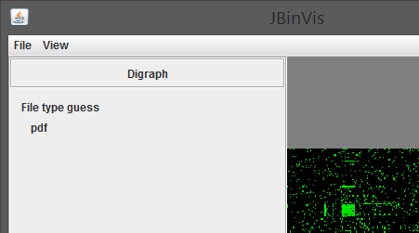

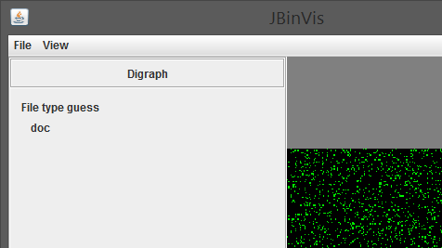

Figure 10 (top) The correct guess for the opened pdf file at offset 0. (bottom) Wrong guess (predicted as a doc file) in another offset within the same file.
Although the approach used produced results that were not accurate enough for practical use, there are a couple of suggestions for improvement.
Firstly, the ConvNet should have been used to classify the fundamental data types (e.g. raw text, uncompressed audio, uncompressed bitmap, etc) instead of overall file types. This is because files of a certain type today can often contain a variety of formatted data within them.
Secondly, regions of a file that contain compressed data (high value of Shannon’s entropy) should not be used to produce digraph visualizations for consumption by the ConvNet. As seen in Figure 11, compressed data exhibit high entropy and little discernible structures in their digraph visualization (akin to attempting to train a network to recognize pattern in a television static image, which is impossible).

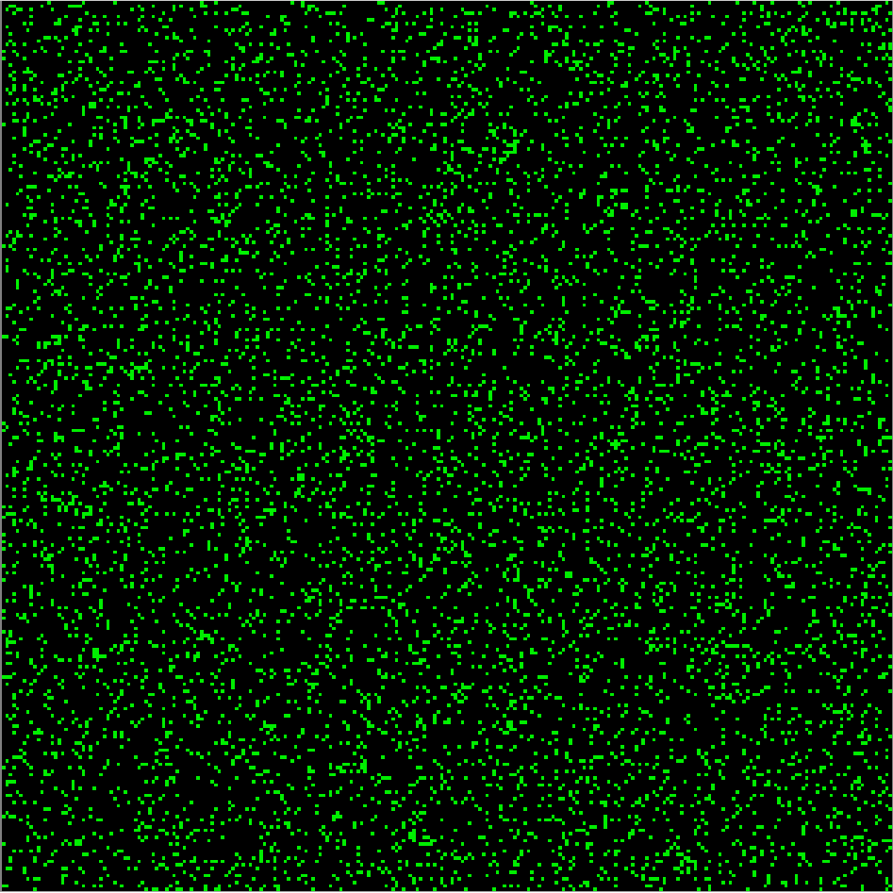

Figure 11 Compressed data as seen in a digraph visualization.
However, it is worth noting that many uncompressed data formats do exhibit some trivial structure in their digraph visualizations that can be passed into an image recognition algorithm. Again, it may be more accurate to classify based on these data formats rather than the overall file type.
Lastly, digraph visualizations can be further supplemented by other statistics (such as byte frequency) in the feature matrix that is passed into the ConvNet.

4 Conclusion
Binvis is superseding the traditional method of analyzing arbitrary sequences of bytes using a hex editor. Though currently available binvis tools are equipped with countless visualizations and aids to ease the file analysis process, the effectiveness of the analysis still heavily depends on the user’s knowledge. To cater for the ever increasing volume of files transferred every day, there is some need for automation in the form of artificial intelligence.
The application developed utilizes a ConvNet to classify digraph visualizations that are generated as the user analyzes a file. However, the approach employed in this research proved to be unreliable due to the set of labels used. It is suggested that, rather than using the general file types as classification labels, the fundamental data formats should be used. Also, when feeding the ConvNet (for training and prediction), digraph visualizations produced from compressed data should be avoided as they contain little information. Digraph data can further be supplemented by other visualizations as well in the feature matrix that will be consumed by the ConvNet.
In spite of the shortcoming, future research can work on implementing the suggestions put forth. Binvis is still a growing field with many possibilities to be explored. If the human mind is able to quickly discern the little nuances within an arbitrary sequence of bytes, computers can be taught to do a similar job, in hopes of improving cybersecurity and the efficiency of general file analysis.

Acknolwledgement
We wish to acknowledge the funding support for this project from Nanyang Technological University under the Undergraduate Research Experience on CAmpus (URECA) programme.
We would also like to acknowledge the technical assistance provided by Irene Goh who manages the GPU-cluster system that was used to train the ConvNet.
Most importantly, we also wish to acknowledge Assoc. Prof. Yeo Chai Kiat for providing support and guidance throughout the project.

References
[1] K. S. Han, J. H. Lim, B. Kang, and E. G. Im, “Malware analysis using visualized images and entropy graphs,” International Journal of Information Security, vol. 14, no. 1, pp. 1–14, 2014.
[2] L. Nataraj, S. Karthikeyan, G. Jacob, and B. S. Manjunath, “Malware images,” Proceedings of the 8th International Symposium on Visualization for Cyber Security - VizSec 11, 2011.
[3] C. Aldo, "binvis.io”, 13 February 2016, http://binvis.io/#/.
[4] CodiSec, “Veles – Binary Analysis Tool”, 2017, https://codisec.com/veles.
[5] G. Conti, E. Dean, M. Sinda, and B. Sangster, “Visual Reverse Engineering of Binary and Data Files,” Visualization for Computer Security Lecture Notes in Computer Science, pp. 1–17.
[6] 4 2 1 Christopher Domas The future of RE Dynamic Binary Visualization. [YouTube video]. Available: https://www.youtube.com/watch?v=4bM3Gut1hIk.

